OudhTrade
Backend Technical Design
Module 2 — Identity & Security · M02-3
Document details
Company | MRIDA INFRA AND PLANTATIONS LLP
Product | OudhTrade — oudhtrade.com
Document | M02-3 Backend Technical Design
Module | M02 Identity & Security (release R1; some items R2)
Readers | Backend developers, DevOps, tech lead
Related documents | PRD (PRD-IDN, PRD-CMP) · HLD · NFR · other M02 documents
Owner | Tech lead
Decision owner | T. Satish Reddy, CEO & Founder
Status | Draft for review — 24 September 2026
Classification | Confidential — for partners and the OudhTrade team

Contents
1. Overview 2
1.1 Services 3
1.2 Keycloak design 4
1.3 What is stored where 6
2. Main Flows 6
2.1 Sign-up (open; invitation optional) 6
2.2 Farmer sign-up by a field agent 7
2.3 Sign-in with risk check 8
2.4 Google or Apple: first sign-in and linking 9
2.5 Account recovery 10
2.6 Contact and account-country change with cooling-off 11
2.7 Delegation to a field agent 12
2.8 Account closure with 30-day grace 13
2.9 Dormant accounts 13
2.10 Account states 14
2.11 Recycled-number reclaim 15
2.12 Invitation roles and “This isn’t my role” 16
2.13 Reminders and notices 16
3. Internal Interfaces 16
4. Public API Endpoints (v1) 17
4.1 Before sign-in 17
4.2 Signed-in users 18
4.3 Field agents and staff 19
5. Events 22
5.1 Events Module 2 publishes 22
5.2 Events Module 2 reacts to 22
6. Jobs and Schedules 23
7. Security Design 24
8. Configuration 25
9. Monitoring 26
10. Threat Model (STRIDE) 27

1. Overview
Module 2 is made of two parts: Keycloak, the sign-in server (its own RDS PostgreSQL database, HLD 5.2 and 6.1), and a set of Module 2 services inside the Core API and the workers (HLD Section 4). Keycloak holds passwords, code secrets, authenticator and passkey credentials, backup codes and sessions; the services hold everything else in the `identity` schema (19 tables, M02-5). Other modules never read these tables; they call the interfaces in Section 3 and react to the events in Section 5. The backend language and framework follow the team’s approved technology proposal (HLD 13.2).
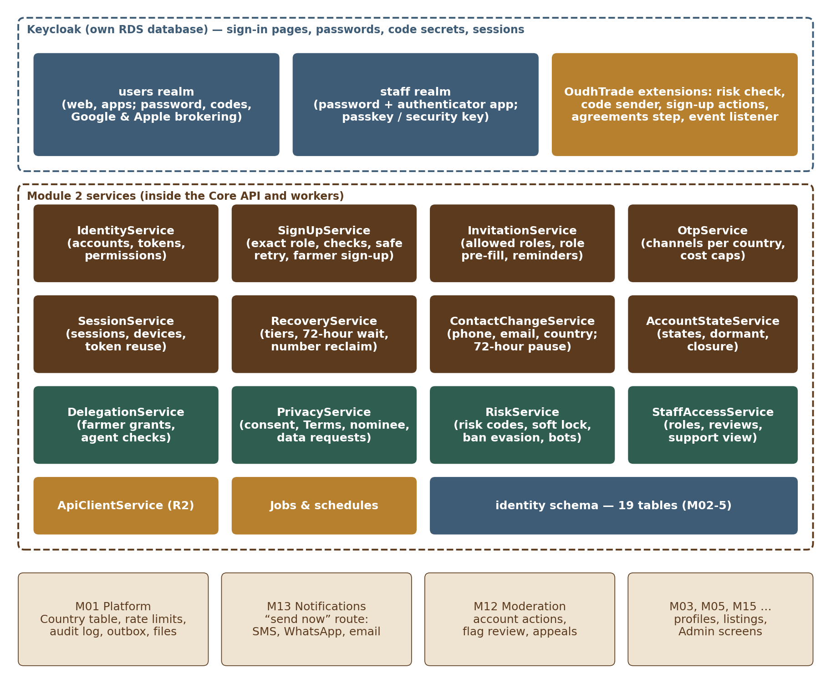
Figure 1 — Module 2 services

1.1 Services
Service | Responsibility | Runs in
IdentityService | Account records, token claims (account ID, roles, state), permission checks for every module, read-only support view (with StaffAccessService), Keycloak event handling | API
SignUpService | Sign-up checks called by the Keycloak sign-up flow: invitation and its allowed roles (when one is used), exact role, one contact per account, country and sanctions check, throw-away email, bot check result (normal or fallback), 18+ and every required agreement line (SUP-031); creates the account exactly once (safe retry); saves language, time zone and sign-up source; farmer sign-up by a field agent, including queued offline sign-ups | API
InvitationService | Invitation codes and links (Admin, field agents, FPOs) with allowed roles, role pre-fill, limits, expiry, tracking, “This isn’t my role” requests and corrected invitations, invitation reminders | API + worker
OtpService | One-time codes: channel order per country from the M01 Country table (otp_channels, sms_sender_registered), sending through the M13 high-priority “send now” route, delivery tracking and next channel, code rules, send limits, daily cost cap per country (OTP-001 to OTP-011) | API (Redis)
SessionService | Session length rules, remembered devices, device list, sign out one or all, refresh-token reuse response, step-up (re-check) for sensitive actions | API
RecoveryService | Recovery tiers, neutral answers, 72-hour wait, ID check with field agent or Support, staff review of verified sellers, 90-day idle rule, backup codes through Keycloak; recycled-number reclaim (Section 2.11) | API + worker
ContactChangeService | Phone, email and account-country changes with two factors, alerts to old and new contacts, 72-hour pause, “This wasn’t me” cancel links | API
AccountStateService | Account states and history, deactivation, dormant scan, closure with 30-day grace and anonymisation, under-18 handling, moderation actions from M12 with suspension end dates, personal details (name, photo; language and time zone through M01 preferences) | API + worker
DelegationService | Farmer-approved delegation to a field agent (request, farmer code, 30-day expiry, cancel), permission check for agent actions, delegation events | API + worker
PrivacyService | Consent purposes (marketing_email, marketing_sms, marketing_whatsapp, personalised_promotions, ai_assist_own_listings), the agreement lines accepted at sign-up, Terms of Use and Privacy Notice re-acceptance, withdrawal of the data-processing consent (leads to account closure), nominee, data requests (download, correction, deletion) with timers | API + worker
RiskService | Risk check at sign-in and sign-up, risk-based codes, soft lock and account lock, mass-guessing block (with the M01 rate limiter), bot-check decisions, throw-away email and internet-number checks, ban-evasion signals, security events | API + worker
StaffAccessService | Staff users and roles, second approver for admin rights, quarterly access review, emergency accounts, joiner / leaver, support read-only access with reason | API + worker
ApiClientService | Partner and AI-agent clients (register, scope changes with approval, keys issued, rotated and revoked, suspend, resume, revoke, usage counts from the call log), user consent grants, Connected apps, expiry, own rate limits (API-001 to API-008) | API + worker

1.2 Keycloak design
Keycloak runs in Mumbai in its own containers with its own small RDS PostgreSQL instance, own backups and a cross-region replica in Hyderabad (HLD 5.2 and 6.1). Web and apps use OpenID Connect with PKCE (HLD 10.1). All pages where a password or code is typed — sign-up, sign-in, code entry, forgot password, Terms re-acceptance, staff sign-in — are Keycloak pages with an OudhTrade theme built from the same component library and design tokens as the web app (M02-4 Section 1.1), so passwords never pass through the Core API.
Part | Design
Realms | users (buyers, sellers, farmers, OudhTrade Partners; later partner and AI-agent clients) and staff (all staff roles including field agents). A person in one realm can never sign in to the other. Clients: users realm — web (confidential client used by the web server, PKCE), mobile (public client, PKCE, R3), partner and AI-agent clients (one confidential client per registered client, “consent required” switched on so Keycloak shows the OudhTrade consent page, M02-6 Section 12.1; the secret is rotated with Keycloak’s client-secret rotation, which keeps the old secret valid for the overlap time); staff realm — admin-app, field-agent screens of the web app.
Sign-up flow | Keycloak sign-up flow with OudhTrade form actions: (1) invitation check, only when the person came with an invitation link (InvitationService; sign-up is open, SUP-008), (2) bot check result, (3) form checks (SignUpService: one phone and one email per account, throw-away domain, country check with declared, phone and IP country, 18+), (4) code to the mobile and, when given, the email (OtpService), (5) password policy, (6) the agreements step “Create your account” (SignUpService checks every required line again — SUP-031), (7) create the Keycloak user and, in the same step, the identity.accounts row through SignUpService (if either fails, both are undone). Step (3) includes the exact role, checked against the invitation’s allowed roles on the server (SUP-017). Step (7) is idempotent: its key is the Keycloak sign-up session plus the confirmed mobile number, so a repeat returns the account already created and signs the person in (SUP-025). The sign-up session lasts at least 60 minutes (setting), keeps non-secret values in the Keycloak session notes, and the theme handles Back and refresh by re-showing the current step (SUP-026). The farmer variant (field agent on their device) adds the language choice, the consent read-out step and the handover to the farmer (Section 2.2).
Browser sign-in flow | Cookie (existing session) → identity-provider redirect (Google or Apple, when chosen) → identifier and password form (mobile number or email, normalised) → account-lock check → OudhTrade risk check (RiskService.assessSignin) → conditional sub-flow: when the risk check asks for it, the authenticator-app code if the user has one, otherwise the OudhTrade code authenticator (OtpService); passkey from R2 → required actions → session. The first-broker and post-broker flows for Google and Apple run the same risk check and authenticator step (SIN-012). Keycloak’s built-in OTP-only and “magic link” options are switched off (SIN-001).
Google and Apple (identity brokering) | Google and Apple are identity providers in the users realm; they are shown per country from signin_methods (SIN-008). A custom “first broker login” flow (Keycloak’s name for the first Google or Apple sign-in): if the provider ID is already linked → sign in. Otherwise the flow never links by email (Keycloak’s “automatically link” and “link by email verification” steps are removed): if an account with that email exists, the user sees “Sign in with your password first, then link Google in Settings” and nothing is linked (SIN-006); if not, the user continues to sign-up completion — invitation in R1, exact role, account country, mobile number with code, 18+ and the agreements step — before any account exists (SIN-005). Apple’s name (sent only on the first authorisation) is written to the Keycloak session at the first callback and later to external_identities, and a relay address is marked (SIN-011). Inside an in-app browser the Google button is not offered (SUP-024). Linking later uses Keycloak’s application-initiated linking after a fresh password sign-in (SIN-007).
Passwords | Password policy: length at least 10 (setting), not the phone or email, breached-password check by a custom policy provider (k-anonymity range check: only the first 5 characters of the password hash leave the server; a local list is the fallback [TBC: service or local list]), no expiry, no history rule. Hash: Argon2id (Keycloak’s argon2 provider; parameters tuned in load tests (starting values in Section 8)). Paste and password managers are never blocked.
Brute-force protection | Keycloak’s built-in brute-force detection is off, because it locks the account at once. It is replaced by the soft-lock rules of RiskService (RSK-002 to RSK-004): after 5 failures a bot check and growing delays, and the IP address or device is blocked through the M01 rate limiter; the account is locked only after 20 failures, and the owner gets an unlock link.
Required actions | Accept new Terms / Privacy (custom action, set by PrivacyService after a material change — PRV-004); add and confirm a mobile number (first Google or Apple sign-in, and after a number reclaim released the old one — REC-012); configure authenticator app (all staff, OudhTrade Partners — STF-002, STF-005); register a security key or passkey (staff Super Admin and Finance — STF-003); update password (after recovery).
Two-step and passkeys | Authenticator app (TOTP, 6 digits, 30 seconds) optional for users (SIN-009), required for all staff. Keycloak recovery codes give the 10 backup codes (REC-005). WebAuthn: staff realm from R1 (security key or platform passkey); users realm passwordless passkeys from R2 as an extra method (SIN-010).
Sessions | Users realm: “remember me” on (30-day session on own device); when the user ticks “Public or shared device”, remember-me is off and the session ends when the browser closes (SES-001, SES-002). Staff realm: 30 minutes idle, 12 hours maximum (SES-005). Access tokens 15 minutes; refresh tokens rotated on every use with reuse allowed 0 times (SES-003).
Event listener | A custom event listener sends Keycloak user and admin events (sign-in, failure, code, password change, credential change, broker link, logout, token refresh error) to the Core API over the internal channel. IdentityService writes security_events, updates accounts (two_step_method, failed_signin_count) and external_identities, and reacts to refresh-token reuse (Section 7).
Calls from Keycloak to Module 2 | The OudhTrade extensions call internal Core API endpoints (`/internal/identity/…`) over the private network with mutual TLS; these endpoints are not reachable from the internet and accept only the Keycloak service identity.
Operations | Realm configuration kept as code (exported realm files in the repository, applied by the pipeline); Keycloak version upgrades tested on staging; admin console reachable only through the VPN; Keycloak admin users are Super Admins with security keys.

1.3 What is stored where
Passwords, code secrets, credentials and sessions are in Keycloak; one-time code challenges, counters and delays are in Redis; everything else is in the identity schema. The full list is in M02-5 Section 11.

2. Main Flows

2.1 Sign-up (open; invitation optional)
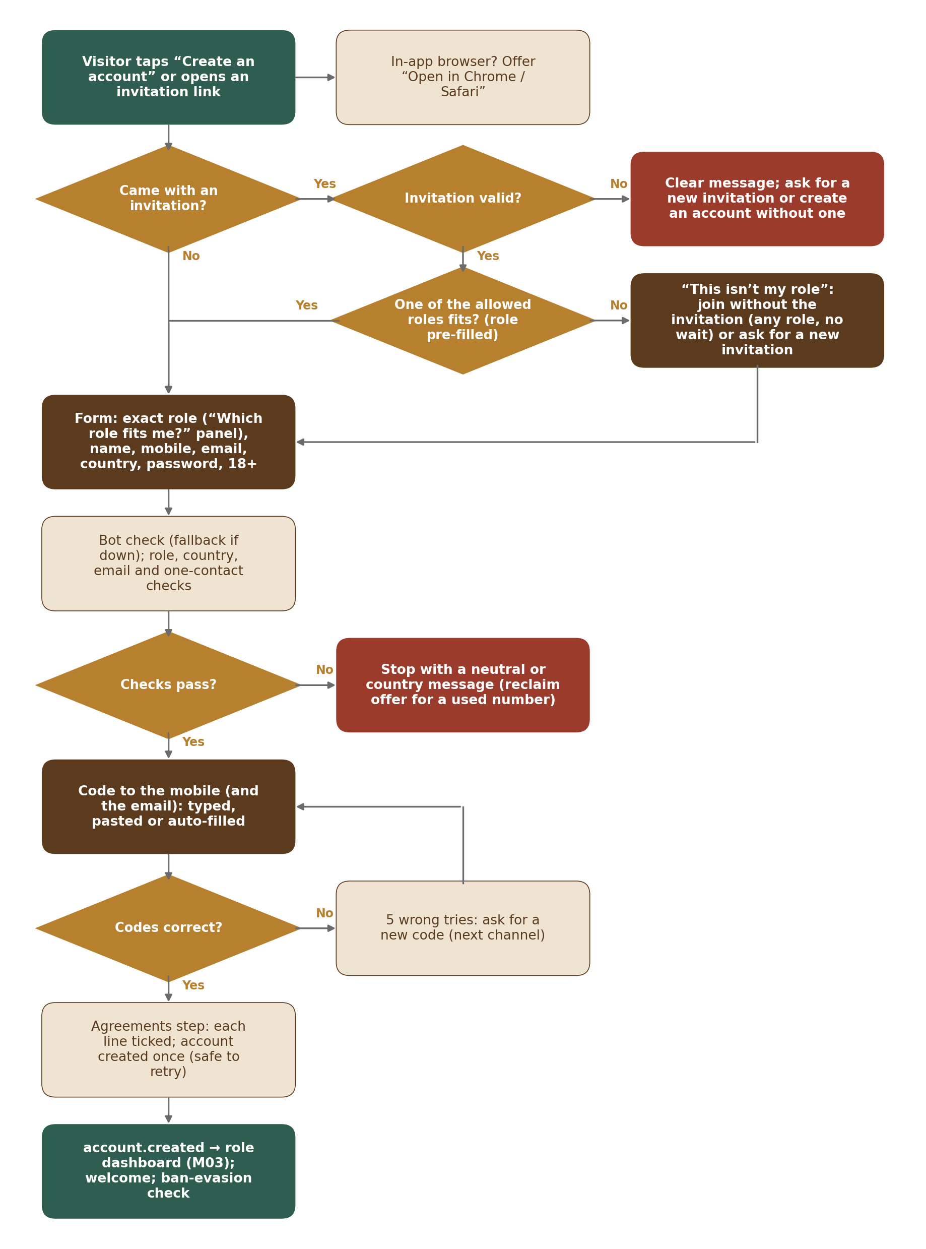
Figure 2 — Sign-up (open to everyone; invitation optional)
Step | What happens
1 | The visitor taps “Create an account” (sign-in page, home page) or opens an invitation link (`/join?code=…`), or taps Join OudhTrade on a seller’s store opened from its share link (`/store/{store-name}?join=1`; the store name is kept in the sign-up session, SUP-032); the invitation landing page also accepts a typed code behind the small link “I have an invitation code” (farmers who got it by SMS or voice call). The page detects an in-app browser and offers “Open in Chrome / Safari” (SUP-024). Without an invitation the flow goes straight to step 2 (SUP-008). With one, InvitationService normalises the code (case, spaces, dashes, look-alike characters — SUP-020) and checks its hash: unused, not cancelled or replaced, not expired (14 days), and returns the allowed roles (SUP-010, SUP-018). Code attempts are limited to 10 per hour per IP; then a bot check (SUP-012). The invitation is marked opened.
2 | The Keycloak sign-up page shows the form: exact role (all six roles; with an invitation only its allowed roles, a single one pre-filled, and the “This isn’t my role” link — SUP-018, SUP-019), name (as on the ID), mobile number, email (optional for farmers), account country, password and “I am 18 or over” (SUP-001, SUP-002, SUP-016). The bot check (AWS WAF CAPTCHA) is passed before the form can be sent (RSK-006); if it is down, the fallback challenge and stricter limits apply and the phone code comes first (RSK-011).
3 | SignUpService checks: phone format (M01), phone country and sign-up IP country; the three countries against the Country table — blocked → refused and logged (SAN-003); email domain against disposable_email_domains (RSK-007); number type (internet numbers allowed but flagged, RSK-008); phone and email not used by another account — if used, the same neutral message in every case (SUP-005). Sign-up is limited to 5 per hour per IP or device (SUP-007).
4 | OtpService sends a code to the mobile number (channel order of the phone’s country) and, when an email was given, a code to the email (SUP-003). Codes are checked in Keycloak form steps; 5 wrong tries stop the code (OTP-002).
5 | The agreements step “Create your account” shows each agreement as a separate line, all unticked; Create my account is disabled until every required line is ticked (SUP-031). Then Keycloak creates the user with the password; SignUpService checks the required lines again and creates accounts (state active, declared_role, display_name from the name typed, has_country_difference, invitation_id, invited_by, sign-up source and campaign tags, referring_profile_id from M03 Profile.byShareLink for a share-link sign-up, bot_check_mode), legal_acceptances (one row per required agreement line and one for the 18+ declaration, each with its version, IP and channel — SUP-004, SUP-027), consents for any optional line ticked (PRV-001) and account_state_history, marks the invitation used (if any) and writes account.created (with the name typed, which M03 copies once to profiles.person_legal_name) to the outbox in the same transaction (SUP-006). It also saves the browser language and time zone to M01 user_preferences (SUP-028). A repeat of this step returns the same account (SUP-025).
6 | After commit: the person lands on the role dashboard (M03, SUP-030), or on the seller’s store after a share link (SUP-032); welcome message through M13; RiskService compares the new account’s signals with banned accounts in the background and, on a match, stores a risk flag and sends account.risk_flagged (RSK-009); a country difference or internet number also raises a flag (SAN-002, RSK-008).

Sign-up is open to everyone from R1; there is no invite-only switch. The waitlist was removed (24 Sep 2026): open sign-up (SUP-013 to SUP-015 removed).

2.2 Farmer sign-up by a field agent
Step | What happens
1 | The field agent is signed in to the staff realm (password + authenticator app) and opens “Sign up a farmer” in the field-agent screens (installable web app). An invitation for a farmer is created by the agent (inviter_type field_agent, allowed role Farmer) or already exists. Agent sign-ups are counted per agent (30 per hour) and the agent’s sign-in replaces the bot check (DEL-010). With no signal, steps 2 and 3 can be done offline and queued on the device; steps 4 to 6 run once there is signal with the farmer present (DEL-011).
2 | The agent fills the form on their device with the farmer’s own mobile number (email optional). SignUpService refuses the agent’s own phone or work email and any number already used (DEL-001).
3 | The farmer chooses the language (English, Hindi, Assamese or Bengali); the consent text is shown in simple words in that language and can be played aloud (recorded audio); the screen asks the agent to hand the phone to the farmer (DEL-003, DEL-012).
4 | A code goes to the farmer’s phone. The message names the purpose (“to create your OudhTrade account with field agent R. Das”) and says OudhTrade will never ask for it; the farmer types it themself, on their own phone or on the agent’s handover screen; if SMS does not arrive, a voice call in the farmer’s language reads it out (DEL-002, DEL-013, OTP-012).
5 | The farmer types their own password on a Keycloak page that the agent’s session cannot read; the field is not saved by the browser and is cleared after sending (DEL-004).
6 | Each agreement line (SUP-031) is read out in the farmer’s language and the farmer ticks each one. The account is created as in Section 2.1 with signup_channel field_agent and signup_agent_id; consents and legal_acceptances store agent_staff_id, time, text version and text language (DEL-003, DEL-012). The agent gets no access to the account (DEL-005); help later needs a delegation (Section 2.7).

2.3 Sign-in with risk check
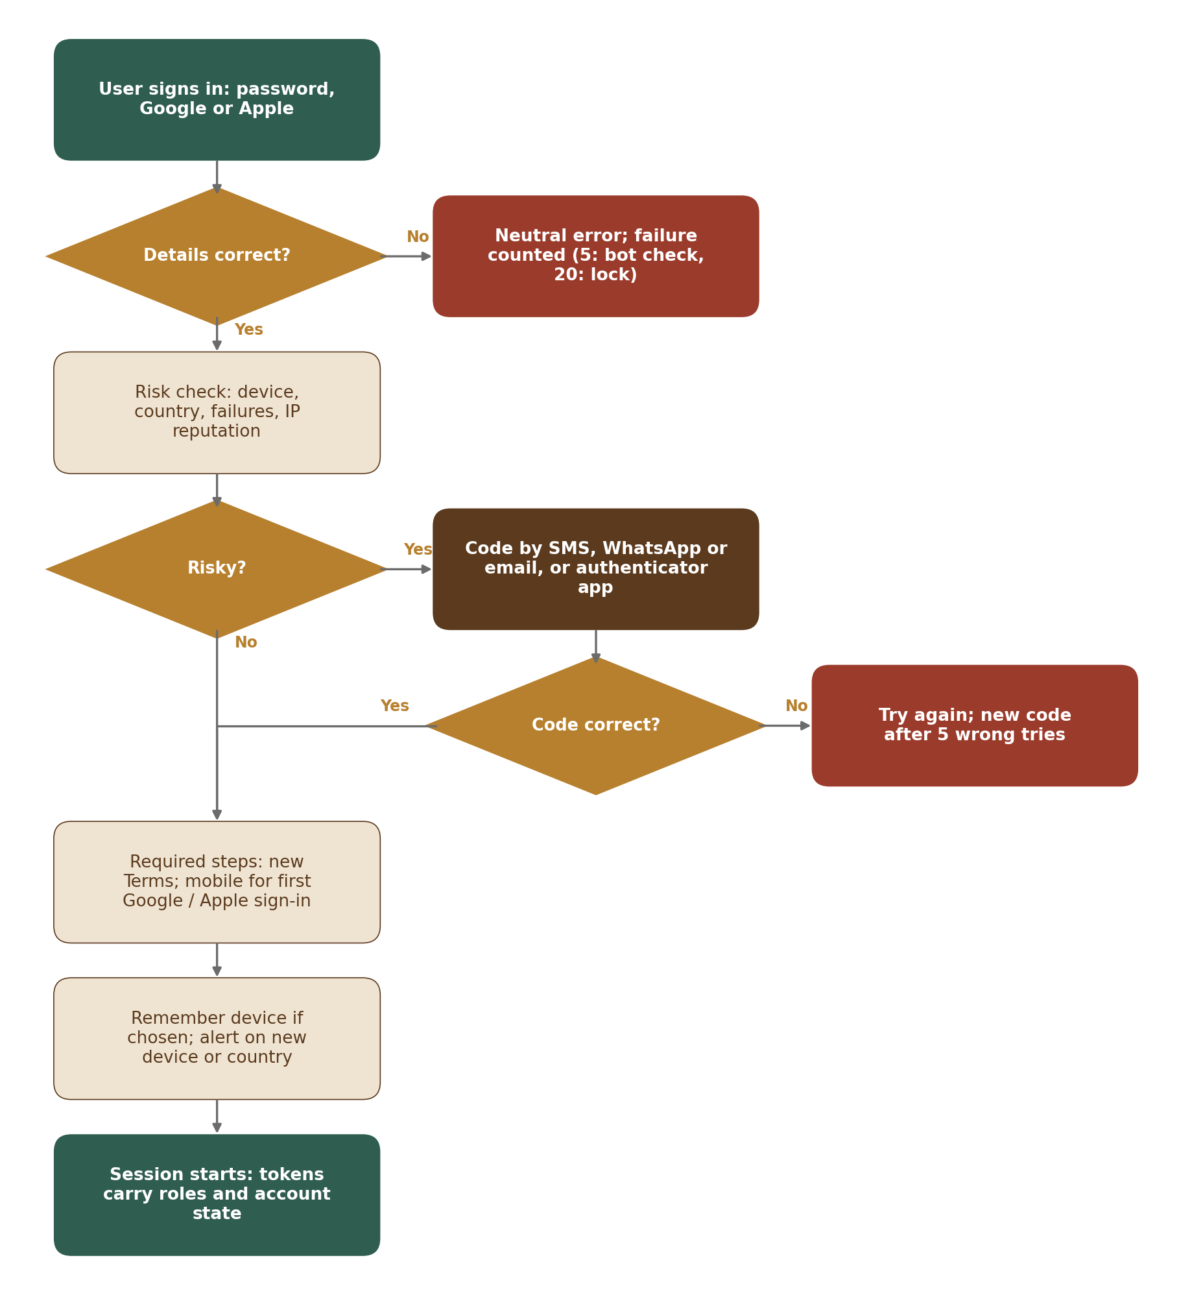
Figure 3 — Sign-in with risk check
Step | What happens
1 | The user types mobile number or email and password on the Keycloak page (or chooses Google or Apple where the country allows it). A wrong password gives the neutral message “Mobile number, email or password is wrong” (SIN-004); for an unknown identifier Keycloak still runs a full password hash, so the answer takes the same time.
2 | Failure handling (RiskService): failures are counted per identifier (a keyed hash of the normalised mobile number or email, whether or not an account exists) and per IP / device in Redis, so an unknown identifier gets the same answers, bot check and delays as a real one. After 5 failures on an identifier: bot check and growing delays (1 s doubling to 30 s), and the IP or device is blocked for 15 minutes through the M01 rate limiter — not the account (RSK-002). After 20 failures the account is locked (accounts.locked_at) and an unlock link is sent by email and SMS (RSK-003); an unknown identifier shows the same “sign-in is paused” message. Many accounts tried from one IP or device → that source is blocked (RSK-004).
3 | Lock check: a locked or anonymised account cannot continue and gets no token. A suspended, banned, dormant or closed (in the 30-day grace) account gets only a restricted token (state claim) that allows only the account-state page, the appeal (suspended or banned), data download, cancelling the closure (closed in the grace) and the full re-check (dormant) (SES-010, ACC-005).
4 | Risk check (RiskService.assessSignin): device cookie matches a trusted_devices row that is still valid? IP country seen before on this account? recent failures? IP on a reputation block list (AWS WAF IP reputation labels and the M01 block list)? The answer is allow, code, or block (RSK-001).
5 | If a code is needed: the authenticator-app code when the user has one, otherwise a code by the country’s channel order (OtpService). On a new device the code screen offers “Remember this device for 30 days” (SES-006).
6 | Required actions: accept new Terms / Privacy if the accepted version is older than the current material version (PRV-004); for a first Google or Apple sign-in, add and confirm a mobile number.
7 | Session starts. The token carries account ID, roles and state (SES-010). Security events are written; a new device or new country sends a security alert with “This wasn’t me” (NTF-001, NTF-004); last_active_at is updated.

2.4 Google or Apple: first sign-in and linking
Step | What happens
1 | The user taps “Continue with Google” or “Continue with Apple” (Google hidden in China and wherever signin_methods leaves it out). Keycloak runs the provider sign-in and receives the provider ID and email.
2 | If external_identities already has this provider ID → normal sign-in (risk check as in Section 2.3).
3 | If not, and an account already uses that email → nothing is linked. The page says: “You already have an OudhTrade account. Sign in with your password, then link Google in Settings.” (SIN-006). The same message is shown whether or not the email is confirmed, so it does not help an attacker who controls a look-alike provider account.
4 | If no account uses that email → sign-up completion: invitation (only when the person came by an invitation link), exact role, account country, mobile number confirmed by code, 18+, then the agreements step (SIN-005, SUP-016, SUP-031); Apple’s name pre-filled (SIN-011). Then as Section 2.1 step 5.
5 | Linking later: Settings → “Link Google” → fresh password sign-in (plus code if the risk check asks) → Keycloak application-initiated linking → external_identities row, security event and alert (SIN-007). Unlinking is allowed only if the account has a password.

2.5 Account recovery
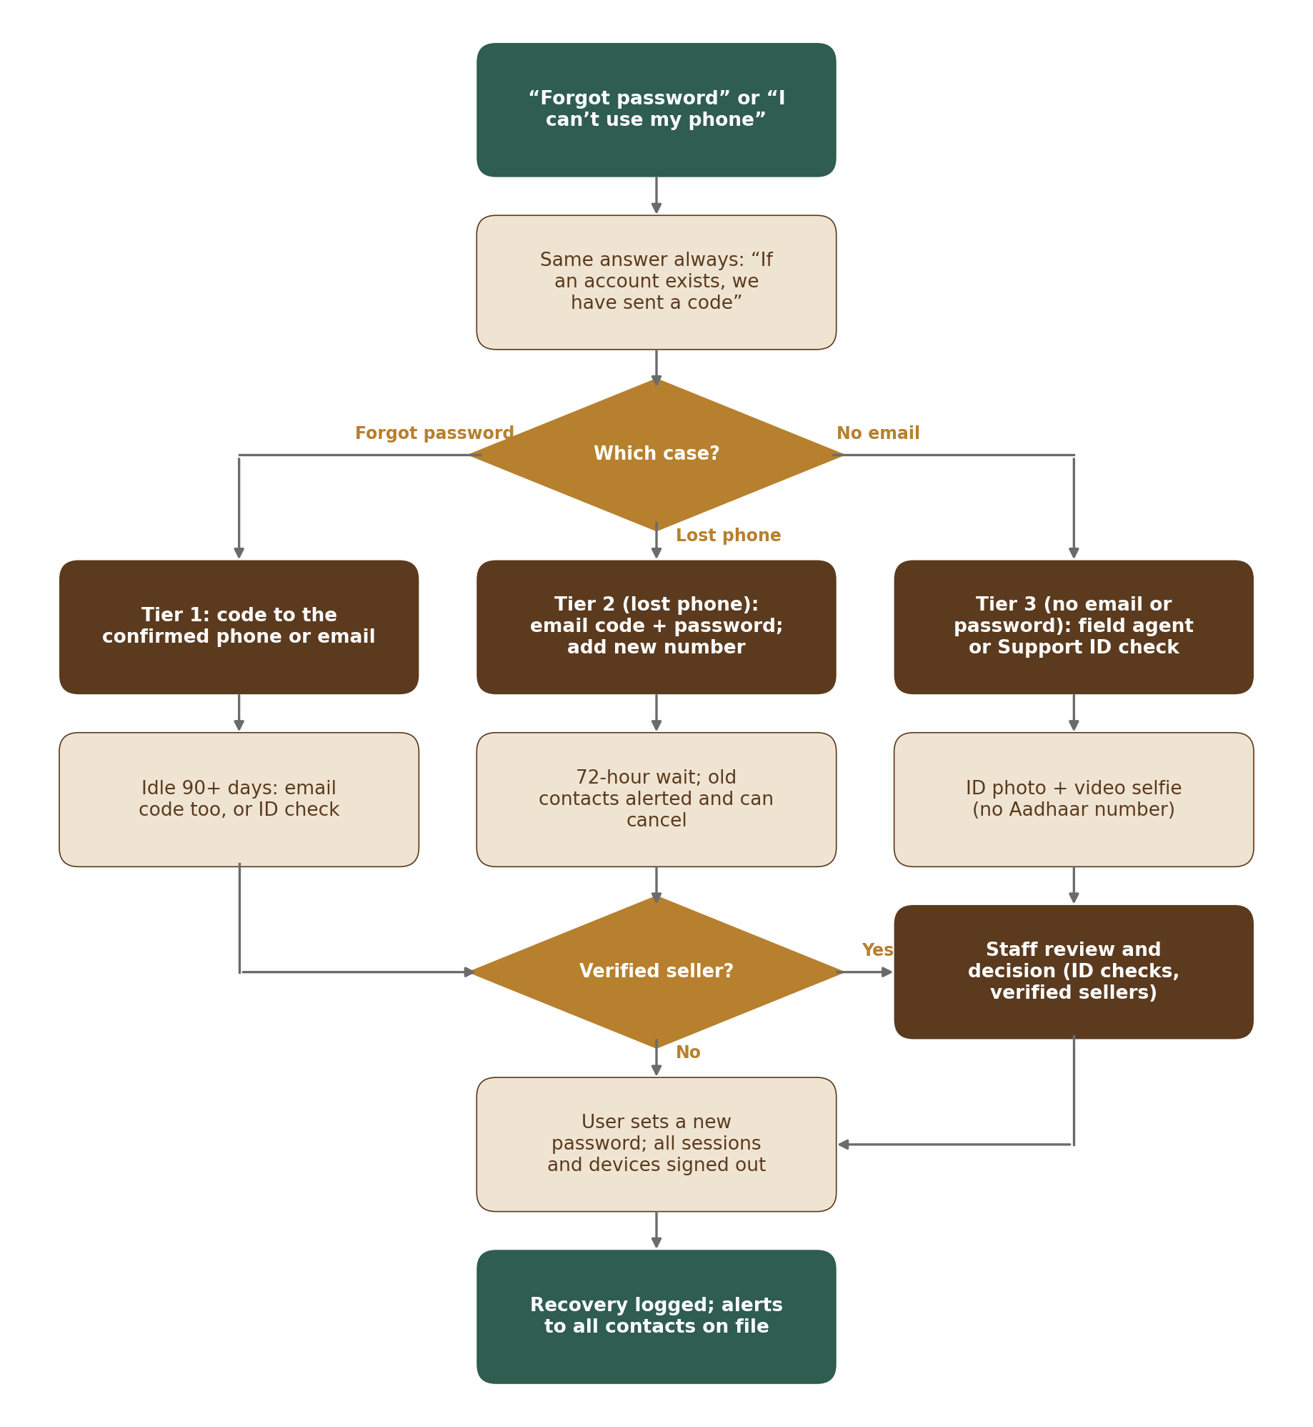
Figure 4 — Account recovery (three tiers)
Step | What happens
1 | Start: “Forgot password” on the sign-in page or “I can’t use my phone”. The page always answers “If an account exists, we have sent a code” (REC-002). The limit of 3 requests per rolling 24 hours is counted per identifier (a keyed hash of the mobile number or email typed), whether or not an account exists, with the same answer, bot check and delays (M02-2 Section 12.2); a request row is stored only when an account matches. A bot check is shown on recovery pages (RSK-006).
2 | Tier 1 — forgot password: a code to the confirmed phone or email (user chooses). If the account has been idle 90 days or more, a phone code alone is not enough: an email code is also needed, or, for farmers without email, a field agent or Support ID check (REC-001, REC-007).
3 | Tier 2 — lost phone: the user confirms with an email code and the password, then adds a new mobile number confirmed by a code. recovery_requests.wait_until = now + 72 hours. Alerts go to the old number and the email with a “Cancel this change” link; any cancel stops it (REC-003). A job activates the new number when the wait ends.
4 | Tier 3 — no email or password (mostly farmers): a field agent or Support opens a recovery case in the staff screens, uploads an ID photo and a short video selfie (private M01 files; an Aadhaar card is not accepted as the ID — the screen asks for another ID such as a voter ID, PAN card or driving licence; the Aadhaar number is never stored — PRV-009), and an Admin or Super Admin approves or rejects (REC-004). Field agents and Support never decide, and nobody decides a case they opened.
5 | Verified sellers: any tier for an account with a verified seller profile (M03 interface) also waits for staff review (REC-006).
6 | Finish: the user sets a new password in Keycloak (staff never see or set it — REC-009). SessionService signs out all sessions and forgets all remembered devices (SES-009); all contacts on file get an alert; security event and audit record are written (REC-008).

Authenticator users can use one of their 10 backup codes instead of the authenticator code in any step; a used code is gone, and a new set replaces the old one (REC-005).

2.6 Contact and account-country change with cooling-off
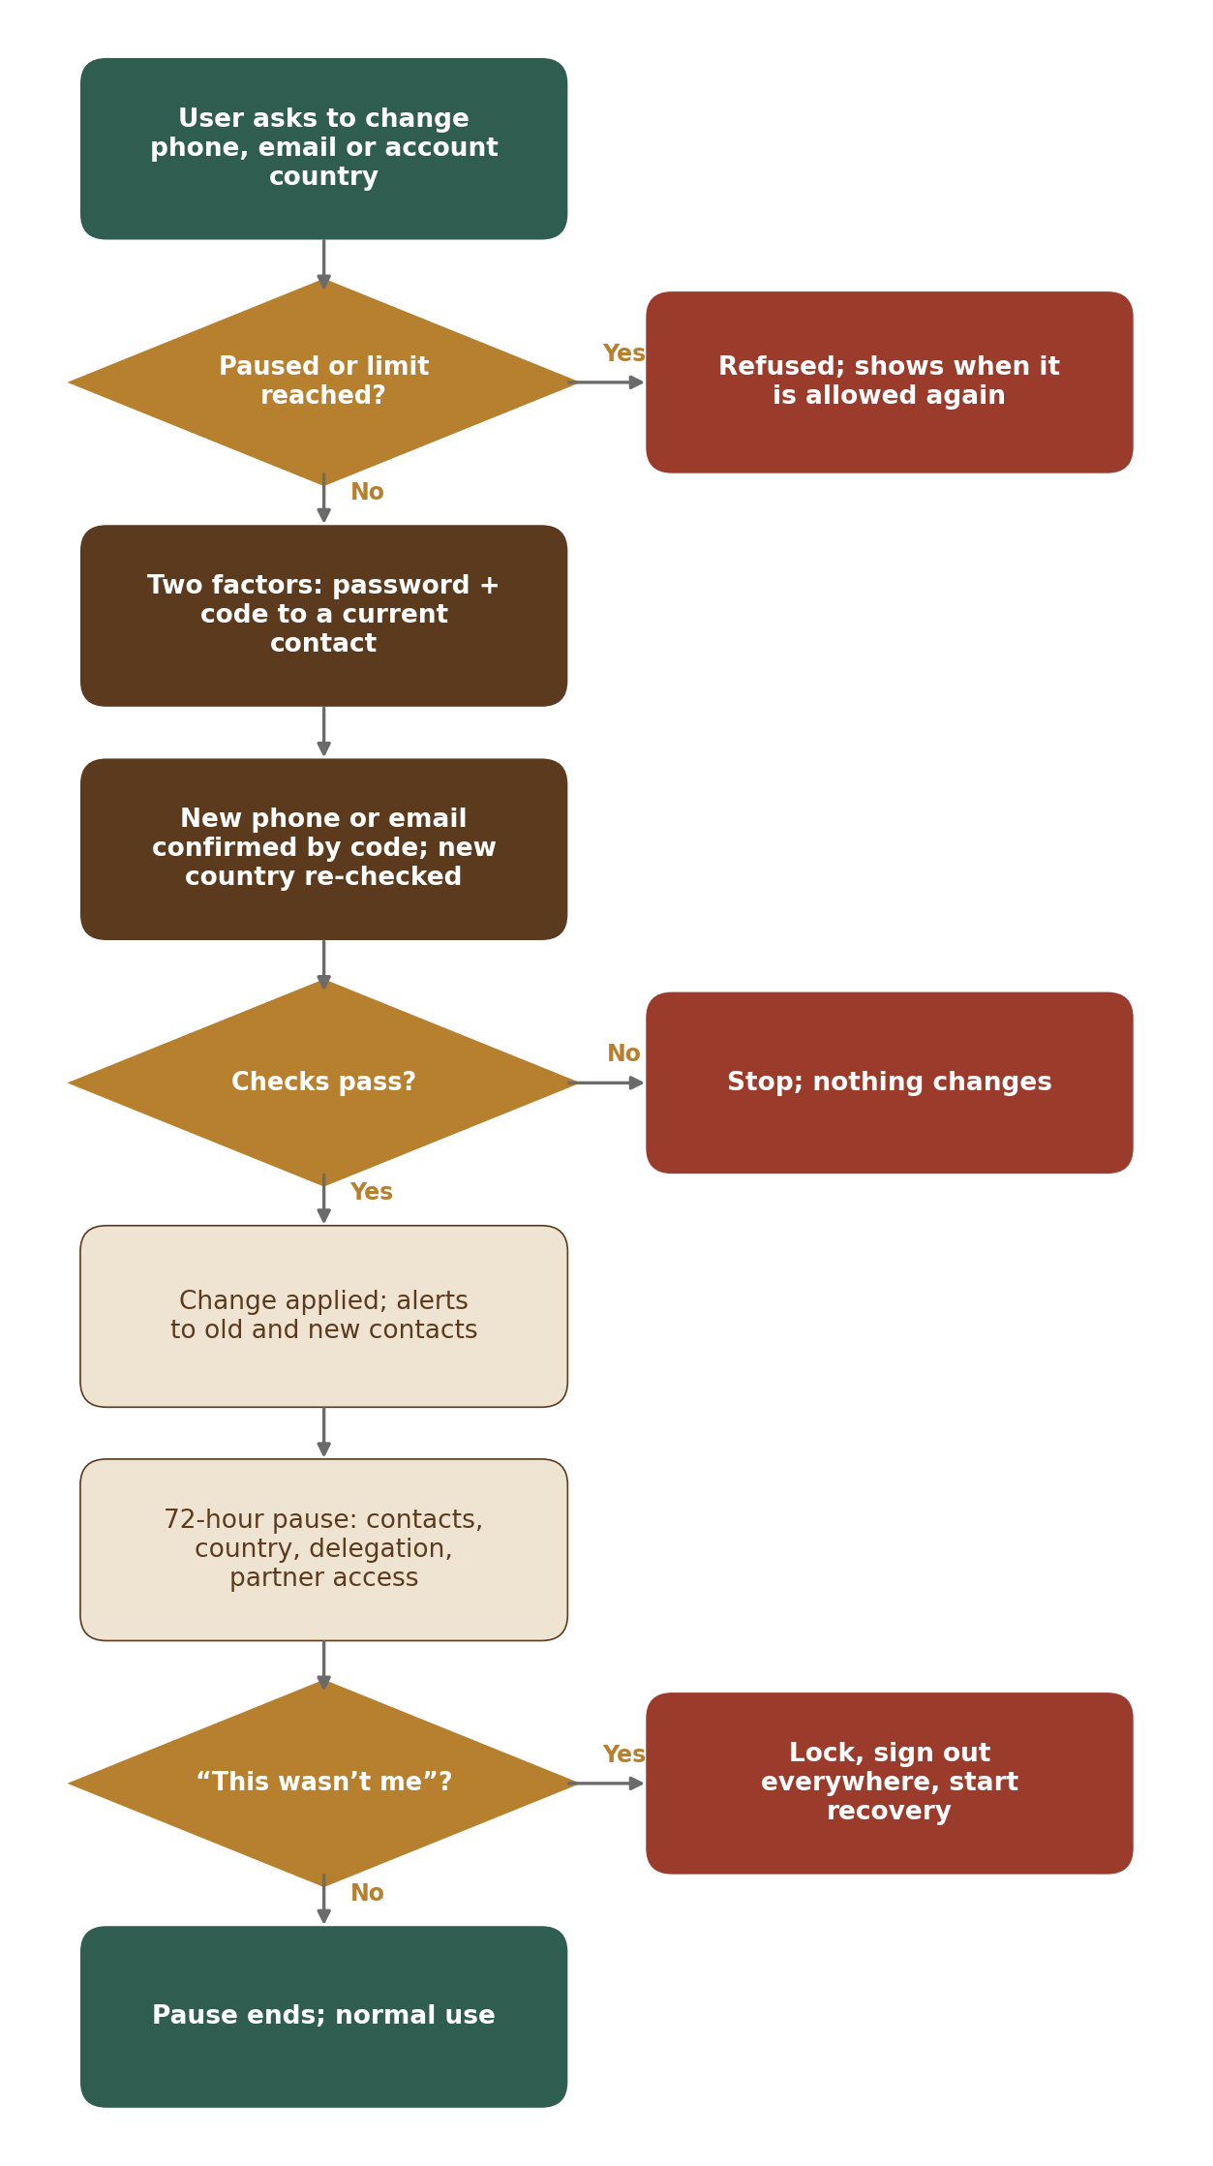
Figure 5 — Phone, email or account-country change
Step | What happens
1 | The user asks to change phone, email or account country in Settings. ContactChangeService refuses if accounts.sensitive_pause_until is in the future or if 3 changes were made in the last 30 days, and shows when it will be allowed (CHG-004, CHG-006).
2 | Two factors: password and a code to a current contact, or the authenticator code (CHG-001). A step-up done in the last 10 minutes counts (SES-007).
3 | Phone or email: a code to the new contact; the new value must not belong to another account (neutral message if it does — CHG-002). Account country: a code, then the country check runs again with the new declared country (CHG-005, SAN-003).
4 | The change is applied; Keycloak’s username attributes are updated; alerts go to the old and the new contact, each with “This wasn’t me” (CHG-003). For phone and email: pause_until = now + 72 hours, copied to accounts.sensitive_pause_until.
5 | During the pause these actions are refused with the end time: another contact change, account-country change, granting delegation, granting partner access (CHG-004).
6 | “This wasn’t me” from any alert locks the account at once, signs out all sessions, forgets devices and starts recovery (NTF-004).

2.7 Delegation to a field agent
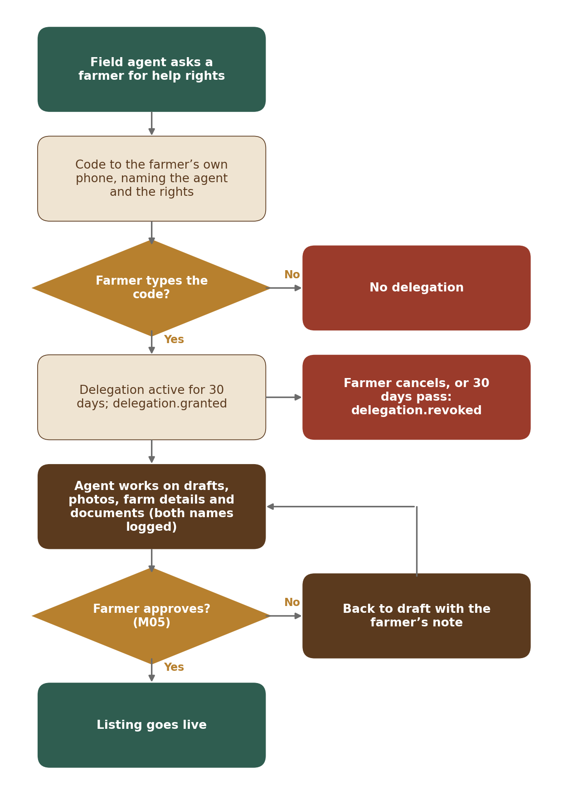
Figure 6 — Field-agent delegation
Step | What happens
1 | The field agent (staff realm) asks for delegation for a farmer: `POST /v1/agent/delegations` with one or more of the four R1 scopes (all four by default). DelegationService checks the farmer account is a farmer, active, not in a contact-change pause, and has no active delegation to this agent. Row status requested.
2 | A code goes to the farmer’s own phone: “Code {code} lets field agent R. Das {rights} for you for 30 days. Type it yourself; do not read it out. OudhTrade will never ask for this code.” {rights} lists the scopes asked, in plain words: make listing drafts, add photos, fill in your farm details, upload your farm documents (DEL-006).
3 | The farmer types the code — on their own phone (Account → Helpers) or on the agent’s phone in a handover screen. Correct code → status active, expires_at = now + 30 days; delegation.granted is sent (to M03, M05, M15); security alert to the farmer.
4 | The agent works on listing drafts in M05 and on the farm profile and verification uploads in M03. For every agent action M05 or M03 calls `Delegation.check(agentId, farmerId, action)`; allowed actions are only listing_draft_edit, photo_upload, farm_profile_edit (farmer profile, “Your trees” basics and Away mode) and verification_upload (identity and verification documents and farm-visit report uploads), and only those in the delegation’s scopes. Nothing else in R1 (DEL-007). The agent never submits for review for the farmer without the farmer’s code confirmation. The audit log records both names (DEL-009).
5 | The farmer approves each listing before it goes live (M05 flow) and can cancel the delegation at any time; the hourly job expires it after 30 days. Either way: status revoked or expired and delegation.revoked (DEL-008).

2.8 Account closure with 30-day grace
Step | What happens
1 | The user asks to close the account in Settings; step-up (password or code) is required (ACC-006, SES-007). Open items are shown first (active plan, open listings, open verification) with the records kept and why, an optional reason and “Deactivate instead” (ACC-012). Deactivation uses the same open-items call and step-up (ACC-011).
2 | AccountStateService sets state closed, closure_requested_at and anonymise_after = now + 30 days; a data_requests row of kind deletion is created with that due date; account_state_history and account.state_changed (to closed) are written; other modules hide the account. A confirmation goes to all contacts.
3 | During the grace the user can sign in and cancel: state back to active, account.state_changed. 3 days before the grace ends (setting), the user is told by email and SMS that the account will be anonymised and how to cancel.
4 | The daily job anonymises accounts past anonymise_after (unless a legal hold applies): a final message is sent by email and SMS before the contacts are cleared; Sign in with Apple tokens are revoked through Apple’s revoke endpoint (Apple account-deletion rule) and Google links are removed (unlinked); Keycloak user deleted; name, phone, email, ban_signals cleared; external_identities and trusted_devices deleted; nominees anonymised; IP cleared in legal_acceptances and consents; anonymised_at set. Then account.closed is sent and each module runs its own anonymiser (Master Database Design, Section 8.3).

2.9 Dormant accounts
Step | What happens
1 | The daily job finds active and deactivated accounts (ACC-011) with last_active_at older than 12 months minus 30 days and sends the first reminder by email and SMS; at 7 days before, the second (ACC-003).
2 | After 12 months: state dormant, dormant_at set, account.state_changed (dormant); listings are hidden by M05 and M07.
3 | Reactivation: the user signs in and passes a full re-check — password plus codes to the phone and the email, or a field agent / Support ID check for farmers (ACC-004). State back to active.

2.10 Account states
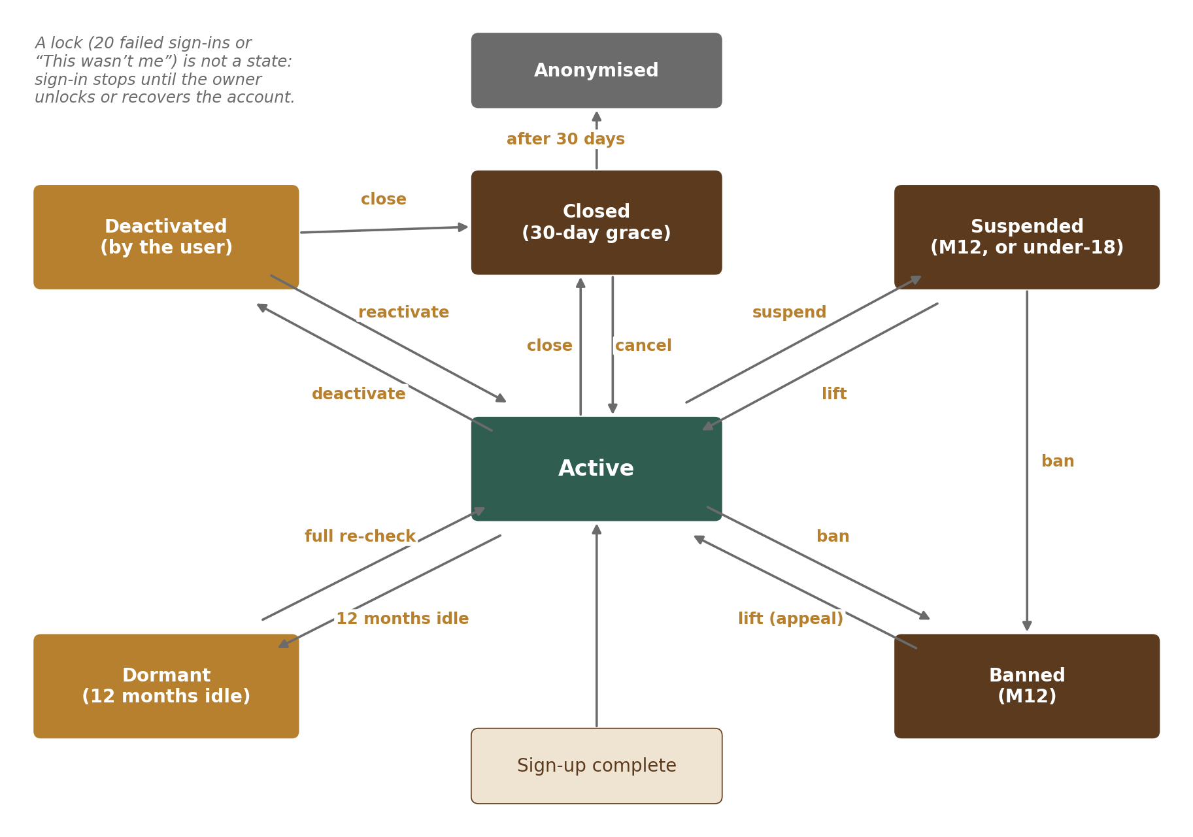
Figure 7 — Account states
States, who sets them and what users and others see are defined in M02-2 Section 8. AccountStateService is the only code that changes accounts.state; every change writes account_state_history and account.state_changed in the same transaction, and SessionService ends the sessions of accounts that become dormant, suspended, banned or closed; after that they get only a restricted token (SES-010). Under-18: when staff confirm a user is under 18 (`POST /v1/admin/accounts/{id}/under-18`, reason required), the account is suspended at once with reason under_18, the person is told why, and after the checks a deletion is scheduled that keeps only records the law requires (ACC-007). Suspension end: moderation.account_action may carry an end date or a lifting condition; they are stored in accounts.state_until and state_lift_condition, and the hourly job returns a suspension past its end date to active unless M12 has extended it (ACC-010). Restricted states: the restricted token keeps the data-rights endpoints open (ACC-009, Section 7).

2.11 Recycled-number reclaim
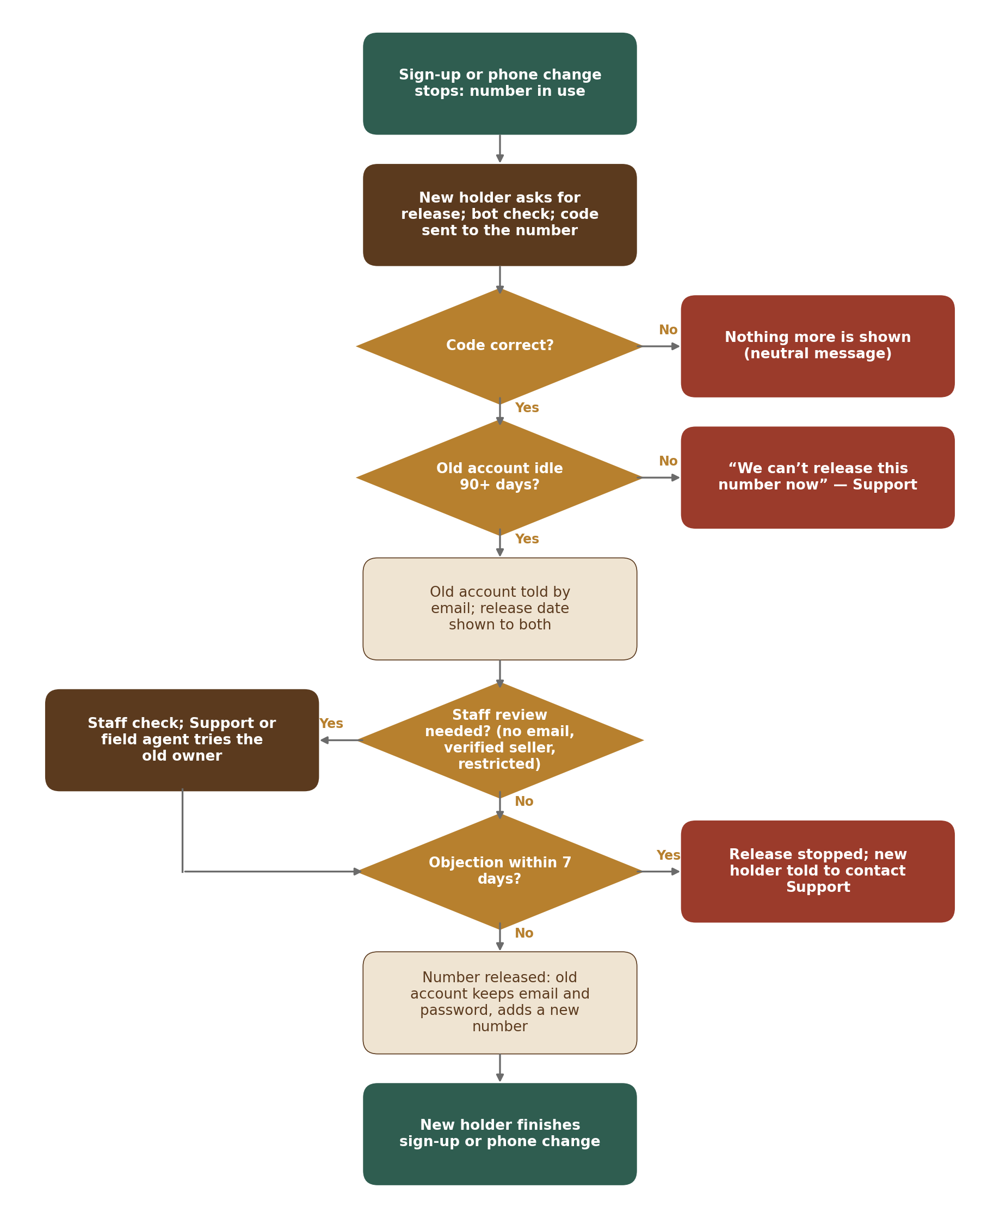
Figure 8 — Recycled-number reclaim
Step | What happens
1 | Sign-up or a phone change stops with the neutral “can’t be used” message (SUP-005, CHG-002), which also offers “Is this number new to you? Ask us to release it”. `POST /v1/auth/number-reclaims` starts it (bot check; 3 per rolling 24 hours per IP or device — REC-013). OtpService sends a code to the number (purpose number_reclaim).
2 | After the correct code (claimant_proved_at), RecoveryService looks up the account holding the number. If there is none, the flow simply returns to sign-up. If the old account’s last_active_at is less than 90 days ago, the answer is “We can’t release this number now. If you need help, contact Support.” and nothing is stored beyond a security event (REC-011).
3 | Otherwise a number_reclaims row is created (status waiting; one open per number). needs_staff_review is set when the old account has no confirmed email, has a verified seller profile (M03 isVerifiedSeller) or is suspended, banned or closing (REC-013). release_after = now + 7 days.
4 | The old account gets an email (M13 send-now route) with the release date and a “This is still my number” link (objection token, keyed hash stored), and an in-app notice at its next sign-in. The claimant sees the same date; an optional email for the outcome can be given (REC-012).
5 | Objection: the link asks the old owner to sign in (password and email code); confirming sets status objected, notifies the claimant (“We can’t release this number. Contact Support.”) and writes a security event. Staff review (when needed) happens in the M15 queue before release_after; Support or a field agent tries to reach the owner; a refusal sets status refused.
6 | The job identity.number_reclaim_release runs hourly: for rows past release_after with no objection (and approved when reviewed) it clears accounts.phone on the old account, sets phone_released_at, signs out its sessions, adds the required action “add a new mobile number” for its next sign-in (email code, since the phone is gone), sets status released and writes security events for both sides. The claimant then finishes sign-up or the phone change with a fresh code. The old account is never opened to the claimant.

2.12 Invitation roles and “This isn’t my role”
Step | What happens
1 | Admin, field agents and FPOs (Company accounts with the Co-operative / FPO badge, checked through M03) create invitations with allowed_roles (Admin any; field agents and FPOs farmer only — database checks and InvitationService). Codes are 16 Crockford base-32 characters (SUP-020).
2 | The invitee who needs another role uses “This isn’t my role” on the landing page or the sign-up form, which offers two choices (SUP-019). “Join without this invitation” needs no call: the page drops the invitation from the sign-up session and the person continues with the open sign-up (any role; no invited_by or invitation_id; sign-up source direct); the invitation stays unused and identity.invitation_reminders skips it once an account exists with the invitee’s contact. “Ask {inviter} for a new invitation” calls `POST /v1/auth/invitations/role-request` with the code, the role needed and an optional note. InvitationService stores it on the invitation (one open request) and routes it: to the FPO or Admin who invited, or to the Admin queue when the inviter may not give that role (SUP-019).
3 | The answer is due within 1 business day (IST business-hours calculator of M01; reminder to the Admin queue when missed). Approve → the old invitation is marked replaced, a new invitation with the corrected role is created (replaced_by_invitation_id) and sent to the same contact. Refuse → the invitee gets the reason.
4 | At sign-up SignUpService refuses any role not in allowed_roles, whatever the page sent (SUP-017).

2.13 Reminders and notices
M02 sends only the reminders listed in NTF-008, through M13 with quiet hours in the person’s time zone. The job identity.invitation_reminders sends the invitee reminder on day 3 and 2 days before expiry while the invitation is sent or opened; dormant and closure notices are in Sections 2.8 and 2.9. Unfinished sign-ups are not stored outside the Keycloak session, so their only reminder is the invitation reminder. Reminders about the “Finish setting up” card are sent by M03, which reads the account and sign-up data from account.created.

3. Internal Interfaces
Other modules call these interfaces inside the Core API; they never query the identity schema.
Interface | Main operations
Identity | refreshClaims(accountId) → the account’s next token refresh gives a token with the current roles and state (M03 calls it after a role or verification change; M02 also calls it on role.changed). The roles claim is read from M03 role_assignments, never from a copy in the identity schema · getAccount(id) → declared role (and buyer kind), display name, state (with end date), account country, two-step on/off, password set · getAccounts(ids) · getStaffUser(id) · currentPrincipal(request) → account or staff user, roles, state, acr (how strongly signed in), auth_time · hasPermission(principal, permission, resource?) → yes / no (checks role, account state, ownership rules registered by the owning module and the configurable permission table) · contacts(accountId, purpose) → phone / email only for M13 sending, never for display
AccountState | isActive(accountId) · state(accountId) · apply(moderationAction{accountId, action: suspend | ban | lift, reason, caseId}) (also driven by the event moderation.account_action). Modules hide or show content by reacting to account.state_changed
Delegation | check(agentStaffId, farmerAccountId, action) → allowed / refused with reason (called by M03 and M05 for every agent action) · active(farmerAccountId) → agent list · request(agentStaffId, farmerAccountId, scopes)
StepUp | require(principal, action, maxAgeMinutes = 10) → ok, or an error that tells the client to run a password or code re-check naming the action (used by M03 for bank or legal details, M11 for billing changes, M02 itself for sensitive actions — SES-007, SES-012). The list of actions is a setting (identity.stepup.actions); users without a password re-check with a code or a fresh Google or Apple sign-in
Consent | get(accountId, purpose) → given / withdrawn with version · list(accountId) · (M13 asks before any marketing message; security messages need no consent)
Otp | send(target, purpose, accountId?) → challenge ID and channel · verify(challengeId, code) → ok / wrong / expired / too many · nextChannel(challengeId). Used by M02 services and, for their own confirmations, by other modules (for example M03 confirming the farmer’s code before an agent submits a verification for review, or opening a remote selfie link) — always through M02, never directly to M13 for codes
Risk | assessSignin(context) · assessSignup(context) · raiseFlag(accountId, kind, signals) · recordSecurityEvent(subject, type, details)
DataExport | register(module, exporter) — each module that holds personal data registers an exporter; PrivacyService calls exportFor(accountId) on each to build the download (profile, listings, messages, reviews…) within 7 days (PRV-006)
Staff | supportView(staffId, accountId, reason) → read-only account view (no passwords, codes, backup codes or private documents), audited (STF-012) · hasStaffRole(staffId, role)
Security messages | notifySecurity(accountId, kind, details) → sends a security alert through M13’s high-priority route with a “This wasn’t me” link; cannot be switched off (NTF-001, NTF-002)

Module 2 depends on these interfaces of other modules: M01 CountryService.get / feature (otp_channels, signin_methods, sms_sender_registered, otp_daily_cost_cap, status), RateLimiter.check / register / block, AuditService.record, EventBus, Jobs, FileService (ID photos, export files), ConsentService (analytics cookie choice), ConfigClient; M13 sendNow(template, channel, destination, priority high) with delivery-status callback; M03 isVerifiedSeller(accountId) and documentNumberHashes(accountId); M17 currentVersion(documentType) with the material-change flag.

4. Public API Endpoints (v1)
Pages where passwords or codes are typed are Keycloak pages (Section 1.2) and use Keycloak’s OpenID Connect endpoints (`/realms/users/…`, `/realms/staff/…`). The Core API endpoints below follow the M01 API rules (errors, idempotency keys, rate-limit headers, cursors — M01-3 Section 4.1). “Step-up” means a password or code re-check in the last 10 minutes.

4.1 Before sign-in
Method & path | Purpose | Who
GET /v1/auth/options?country= | Sign-in methods and code channels for a country (from the Country table) | Public
POST /v1/auth/invitations/verify | Check an invitation code; returns the inviter type and the allowed roles (SUP-010, SUP-018); 10 per hour per IP, then bot check | Public
POST /v1/auth/invitations/role-request | “This isn’t my role”: code, role needed, optional note (SUP-019) | Public (valid code)
POST /v1/auth/invitations/renew-request | “Ask for a new invitation” for an expired or cancelled code; tells the inviter (SUP-022) | Public (code, bot check)
POST /v1/waitlist · /v1/waitlist/confirm · /v1/waitlist/remove | Removed (24 Sep 2026): open sign-up | —
POST /v1/auth/number-reclaims · POST …/{id}/verify · GET …/{id} | Ask to release a recycled number; prove it with the code; see the release date and status (REC-010 to REC-012) | Public (bot check; reclaim session)
POST /v1/auth/number-reclaims/object | “This is still my number” from the email to the old account; confirmed after password and email code (REC-013) | Public (token) + sign-in
POST /v1/auth/recovery | Start recovery (tier chosen); always the same answer (REC-002) | Public (bot check)
POST /v1/auth/recovery/{id}/new-phone | Lost phone: add the new number after email code and password (REC-003) | Recovery session
POST /v1/auth/recovery/cancel | Cancel a recovery or contact change from the link sent to an old contact | Public (token)
POST /v1/auth/unlock | Unlock a locked account with the link sent by email or SMS (RSK-003) | Public (token)
POST /v1/auth/this-wasnt-me | “This wasn’t me” from a security alert: lock, sign out all, start recovery (NTF-004) | Public (token)

4.2 Signed-in users
Method & path | Purpose | Who
GET /v1/me | Own account: declared role, state (with reason, end date or lifting condition and appeal link), two-step, password set, pause end, contact delivery problems, required actions | Signed-in users (also restricted token)
GET · PATCH /v1/me/personal | Personal details: display name, profile photo, preferred language, time zone (with how it was set), language for codes and calls (accounts.code_language); legal name read from M03; add an email (farmers) (CHG-007 to CHG-009) | Signed-in users
GET /v1/me/devices · DELETE /v1/me/devices/{id} · POST /v1/me/devices/{id}/forget | Signed-in devices and remembered devices; sign out one device (SES-008); forget a remembered device (SES-011) | Signed-in users
POST /v1/me/sessions/sign-out-all | Sign out all devices (also forgets remembered devices) | Signed-in users
GET /v1/me/security-events | Sign-in and security history, 12 months, cursor-paged | Signed-in users
POST /v1/me/contact-changes · POST …/{id}/verify · DELETE …/{id} | Start, confirm or cancel a phone, email or account-country change | Signed-in users (step-up)
GET /v1/me/linked-sign-ins · DELETE /v1/me/linked-sign-ins/{provider} | Google and Apple links; unlink (only with a password). Linking uses Keycloak application-initiated linking | Signed-in users (step-up to unlink)
Keycloak actions: UPDATE_PASSWORD, CONFIGURE_TOTP, recovery codes, webauthn (R2) | Change or set a password (current password, or code / fresh Google or Apple sign-in when none is set; 5 attempts per hour — SIN-013, SIN-014), switch on the authenticator app, make a new set of backup codes, add a passkey | Signed-in users (step-up)
GET /v1/me/open-items | What deactivation or closure would affect, in the account’s own numbers (live listings, open enquiries, plan, open verification) (ACC-011, ACC-012) | Signed-in users
POST /v1/me/deactivate · POST /v1/me/reactivate | Deactivate or reactivate own account (ACC-002, ACC-011) | Signed-in users (step-up)
POST /v1/me/closure · DELETE /v1/me/closure | Close the account; cancel during the 30-day grace (ACC-006) | Signed-in users (step-up)
GET /v1/me/consents · PUT /v1/me/consents/{purpose} | Consent choices with a one-line description and what changes on withdrawal; give or withdraw (PRV-002, PRV-010) | Signed-in users (also restricted token)
GET /v1/me/privacy-contacts | Grievance Officer name, email, address and response times; grievance and Grievance Appellate Committee links (PRV-011; text from M17) | Signed-in users (also restricted token)
GET /v1/me/legal · POST /v1/me/legal/accept | Accepted versions; accept new Terms / Privacy | Signed-in users
GET · PUT · DELETE /v1/me/nominee | Nominee (PRV-005) | Signed-in users (step-up to change)
GET /v1/me/data-requests · POST /v1/me/data-requests | List and create download or correction requests, including the failed state (PRV-006, PRV-007, PRV-012) | Signed-in users, also restricted token (step-up for download)
GET /v1/me/data-requests/{id}/files | The JSON, CSV and PDF files are kept 7 days; each click makes a new 5-minute signed link to one file (NFR 6.1) | Owner (signed in)
GET /v1/me/delegations · POST …/{id}/approve · POST …/{id}/revoke | Farmer: see requests and active helpers, approve with code, cancel (DEL-006, DEL-008) | Farmers
GET · POST · DELETE /v1/me/invitations | FPOs invite their member farmers (farmer only; open-invitation limit) and cancel unused invitations (SUP-009, SUP-021) | FPOs (Co-operative / FPO badge)
GET /v1/me/api-grants · DELETE /v1/me/api-grants/{id} | Connected apps: each client the user allowed, with partner, scopes, given on, last used, ends on and status (active, stopped by OudhTrade, ended); stop access at once — tokens revoked in Keycloak, security event written (API-004, API-008). The consent itself is given on the Keycloak consent page; an event-listener call (`/internal/identity/api-grants`) stores the grant in api_grants and sends the security message (API-003, API-007) | Signed-in users, also restricted token

4.3 Field agents and staff
Method & path | Purpose | Who
POST /v1/agent/invitations | Invite a farmer (farmer type only) | Field agents
POST /v1/agent/farmer-sign-ups | Start a farmer sign-up on the agent’s device (also a queued offline sign-up once online, with its idempotency key); returns the Keycloak sign-up link for the handover; limited per agent (DEL-010, DEL-011) | Field agents
GET /v1/agent/delegations · POST /v1/agent/delegations | My farmers and their delegation status; ask a farmer for delegation | Field agents
POST /v1/agent/recovery-checks | Open a tier-3 recovery case and upload the ID photo and video selfie the user sends (REC-004); the opener can never decide the case | Field agents, Support
POST /v1/admin/recovery-requests/{id}/notes · POST /v1/admin/number-reclaims/{id}/notes | Add a note or a contact attempt to a recovery or reclaim case; notes are never shown to the user (STF-012) | Support, Admin, Super Admin
GET · POST /v1/admin/invitations · DELETE …/{id} · POST …/{id}/resend · POST …/{id}/replace | List all invitations; invite one person or a list with allowed roles, from our team or on behalf of an FPO or field agent; cancel, resend (once per 24 hours) and replace, with a reason (SUP-009, SUP-018, SUP-033) | Admin, Super Admin
GET /v1/admin/fpo-invitation-limits · PUT …/{profileId} | Open-invitation limit per FPO; change it with a reason (SUP-009, SUP-033) | Admin, Super Admin
GET /v1/admin/invitation-role-requests · POST …/{id}/decision | “This isn’t my role” queue; approve (corrected invitation) or refuse with a reason (SUP-019). FPOs answer their own through GET · POST /v1/me/invitations/role-requests | Admin
GET /v1/admin/number-reclaims · POST …/{id}/decision | Number reclaims that need staff review; approve or refuse before the release date (REC-013) | Admin, Super Admin decide (Support: view only)
GET /v1/admin/accounts?q= · GET /v1/admin/accounts/{id} | Account search (name part, full mobile number or email, account ID; results masked) and account view; header X-Access-Reason required to open an account; every view audited; Support gets the read-only summary (STF-012, STF-016) | Support, Admin, Moderator, Super Admin
POST /v1/admin/accounts/{id}/state-actions | Apply or end a suspension, or reactivate after a successful appeal, only with a matching M12 decision number; reason required (ACC-013) | Admin, Super Admin
POST /v1/admin/accounts/{id}/reveal-contact | Show one full contact in a recovery or reclaim case for 60 seconds; reason required; logged (STF-016) | Admin, Support
GET /v1/admin/delegations · GET …/{id} · POST …/{id}/revoke | Delegations with the agent action log; revoke with a reason; farmer and agent told (DEL-014) | Admin, Super Admin (view: Moderator, Support)
GET /v1/admin/recovery-requests · POST …/{id}/decision | Recovery review queue; approve or reject (not the person who opened the case) | Admin, Super Admin decide (Support: view only)
GET /v1/admin/data-requests · GET …/{id} · POST …/{id}/assign · POST …/{id}/complete · POST …/{id}/reject | Data-requests queue for all accounts (filters: type, status, due, legal hold, account country, handled by); each row carries the account’s legal-hold state read from M01 (M01-6 Section 12.10); complete and refuse need a reason; completing an erasure or deleting files is refused while a hold is on (LEGAL_HOLD_ACTIVE) (PRV-006 to PRV-008, PRV-013) | Admin, Super Admin (view: Support)
GET /v1/admin/risk-flags · POST …/{id}/review | Risk and ban-evasion flags (review happens in M12; this is the M02 record) | Moderator
POST /v1/admin/accounts/{id}/under-18 | Confirm a user is under 18 (reason required) (ACC-007) | Admin
GET /v1/admin/settings/disposable-email-domains · POST …/drafts · POST …/import · POST …/test | Throw-away email domain list (RSK-007): list; a draft that adds or retires domains with a reason; import a list file into a draft; test an address against the live list and the draft. Drafts are previewed, approved and published through the M01 settings service (common settings pattern, M01-6 Section 12.1) | Admin, Super Admin (view: Moderator)
GET · POST /v1/admin/staff · POST …/{id}/roles · POST …/{id}/roles/approve · POST …/{id}/leave | Staff users; role request and second approval; leaver (STF-006, STF-010) | Super Admin
GET /v1/admin/access-reviews · POST …/{id}/confirm · POST …/{id}/sign-off | Quarterly access review: decide each person (not your own), then sign off (STF-008, STF-015) | Super Admin
DELETE /v1/admin/staff/{id}/credentials/{credentialId} · GET /v1/admin/emergency-accounts | Remove a lost security key (STF-003); emergency account status, view only (STF-009) | Super Admin
POST /v1/admin/security-actions · GET …/{id} · POST …/{id}/approve · POST …/{id}/stop · POST …/{id}/retry-failed | Bulk security action after a breach or incident: sign out and force a password reset for a chosen group of accounts; incident reference required; preview count and sample; runs only after a second approver; progress, stop and retry; affected users told through M13 (STF-013, DevOps & Engineering Standards 11) | Super Admin
GET · POST /v1/admin/api-clients · GET …/{id} · GET …/{id}/usage | Partner and AI-agent clients: list, register (waits for approval), detail and usage for 30 days (API-001, API-005, API-006) | Admin, Super Admin
POST /v1/admin/api-clients/{id}/scope-changes · POST …/scope-changes/{changeId}/approve · …/reject | Ask for a new client’s scopes or a scope change, with a reason; approved as a high-impact change (M01-6 Section 12.1), never by the person who asked (API-002, API-006) | Admin asks; Super Admin approves
POST /v1/admin/api-clients/{id}/keys · POST …/keys/rotate · DELETE …/keys/{keyId} | Issue the first key (shown once), rotate (old key valid for the overlap time or stopped at once), revoke a key (API-001, API-004, API-006) | Admin, Super Admin
POST /v1/admin/api-clients/{id}/suspend · …/resume · DELETE …/{id} | Suspend (calls refused, grants paused), resume, or revoke the client for good (grants ended, users told through M13); reason required (API-004, API-006) | Admin, Super Admin

The staff screens for these endpoints are specified in M02-6 Section 20 and built in the M15 Operations Console layout (the throw-away email domain list is a settings screen in the M16 Configuration Console shell); staff endpoints are reachable only from the Admin app network path (VPN / IP allow-list, STF-004), except the `/v1/agent/…` endpoints, which field agents reach from the public web app with a staff-realm session. To users and to callers who are not signed in, admin and staff endpoints answer 404, not 403 (STF-014). Every error code these endpoints return, with its HTTP status and message, is in the error and message catalogue, M02-6 Section 19.

5. Events
Event names follow the platform event catalogue; the full list of events, publishers and users is in HLD Appendix B. Events are written to the M01 outbox in the same transaction as the change.

5.1 Events Module 2 publishes
Event | When | Used by
account.created | Account created (Section 2.1); payload: account ID, name as typed (for the M03 profile legal name), declared role and buyer kind, allowed_roles (from the invitation, empty when none), account country, invitation source, sign-up channel, sign-up language, sign-up source and campaign tags, referring seller profile (share link, SUP-032) | M13 (welcome), M18 (counts), M11 (referring seller for Founding Seller benefits); M03 creates the profile and role, and starts its setup reminders
account.state_changed | Any state change: active, deactivated, dormant, suspended, banned, closed (grace starts); payload: old and new state, reason code | M03, M05, M07, M09, M12 (and M10, M11)
account.closed | After the 30-day grace, when the account is anonymised | M01 (retention), M03, M05, M07, M09, M10
delegation.granted / delegation.revoked | Farmer grants, cancels, or the delegation expires; payload: delegation ID, farmer ID, agent ID, scopes, expiry | M03, M05, M15
account.risk_flagged | Ban-evasion match, internet number, country difference, suspected takeover, token reuse, account linked to a newly blocked country | M12 (review queue)
consent.changed | A consent purpose given or withdrawn (including the analytics cookie choice made in Settings) | M13, M18

5.2 Events Module 2 reacts to
Event (from) | What Module 2 does
moderation.account_action (M12) | AccountState.apply: suspend (with an optional end date or lifting condition) or ban with reason and case ID (sessions end, appeal link built from the case), or lift (back to active); state history and account.state_changed
config.published (M01) | Refresh Module 2 settings and the country rules (channels, sign-in methods, cost caps, blocked countries). A country newly blocked → accounts linked to it are flagged for review, not closed (SAN-004)
role.changed (M03) | Identity.refreshClaims for the account: the next token refresh reads the roles from M03 role_assignments, so the new role is in the token within 15 minutes; no session is ended
profile.verified (M03) | No state change; the recovery rule for verified sellers reads the current status through the M03 interface at the time of recovery
legal_hold.placed / legal_hold.released (M01) | Pause or resume anonymisation and deletion jobs for the held account

Handlers store processed event IDs (M01 processed_events) and are safe to run twice. Security events (security_events) are not catalogue events: they are written to the table and streamed to the security log and monitoring.

6. Jobs and Schedules
All jobs use the M01 job runner and scheduler (retries, dead-letter list, staff re-run). Times are IST.
Job / schedule | When | What it does
identity.dormant_scan | Daily 03:00 | Active and deactivated accounts: reminders at 30 and 7 days before 12 months idle; then state dormant and account.state_changed (ACC-003, ACC-011)
identity.suspension_expiry | Hourly | Return suspended accounts past state_until to active unless M12 extended them; account.state_changed (ACC-010)
identity.number_reclaim_release | Hourly | Release numbers of reclaims past release_after with no objection (and approved when reviewed); remind staff of reviews due (REC-012, REC-013)
identity.invitation_reminders | Hourly (sends only outside quiet hours in the invitee’s time zone) | Invitee reminders on day 3 and 2 days before expiry (none once an account exists with the invitee’s contact); role-request answers overdue → Admin queue alert (NTF-008, SUP-019)
identity.closure_anonymise | Daily 03:30 | Final notice 3 days before the grace ends; anonymise closed accounts past the 30-day grace (skips legal holds), with a last message, Apple token revoke and Google unlink; account.closed (ACC-006)
identity.under18_delete | Daily 03:45 | Delete personal data of under-18 cases once staff mark the checks done; keep legal records (ACC-007)
identity.invitation_expiry | Hourly | Mark invitations expired; clear invitee contact 30 days after use or expiry; delete old unused ones
identity.delegation_expiry | Hourly | Expire delegations past expires_at; delegation.revoked (DEL-008)
identity.recovery_timers | Every 5 minutes | Activate new phone numbers whose 72-hour wait ended; expire unfinished requests; ask M01 to delete ID media after decisions
identity.data_request_timers | Hourly | Remind staff 2 days and 1 day before the due date; alert the tech lead and Grievance Officer when overdue; retry failed downloads (3 times) and alert staff (PRV-012); delete export files after 7 days (PRV-008)
identity.access_review | 1 Jan, 1 Apr, 1 Jul, 1 Oct | Open the quarterly staff access review; reminders weekly; access not confirmed within 14 days (configurable) is removed (STF-008)
identity.leaver_check | Daily 18:00 | Staff with left_on today still active → disable in Keycloak, end sessions, alert Super Admins (STF-010)
identity.trusted_device_cleanup | Daily | Delete remembered devices 30 days after expiry or revoke
identity.security_events_partitions | Monthly (25th) | Create next month’s partition; drop partitions older than 12 months
identity.ban_signal_cleanup | Daily | Clear ban_signals past their retention period [TBC: C10]
identity.otp_cost_watch | Every 5 minutes | Compare each country’s code cost for the calendar day (UTC) with otp_daily_cost_cap; at 80 % alert, at 100 % stop SMS and WhatsApp codes to that country until the end of that day (email still works); detect spikes (OTP-008)
identity.api_secret_rotation | Daily | Warn Admin and the partner 14 days before a client secret expires; expire grants (API-004)

7. Security Design
Area | Design
Tokens | Keycloak issues signed JWT access tokens (asymmetric keys, rotated yearly (starting value, configurable); old keys kept for verification until tokens expire). Lifetime 15 minutes. Claims: sub = account or staff ID, realm, roles (read from M03 role_assignments; refreshed by Identity.refreshClaims), account state, acr (how the user signed in: password, code, authenticator, passkey), auth_time, session ID, audience. The Core API checks signature, audience, expiry and realm on every call and re-reads the account state from a short cache (60 s) so a suspension applies at once even before the token expires. A restricted token (state not active) is accepted only by the account-state, appeal, data-rights (download, consents, correction request, privacy contacts, grievance link), Connected apps (list and stop access, API-008), device list (suspended), closure-cancel and re-check endpoints (SES-010, ACC-009).
Refresh-token rotation and reuse | Every refresh returns a new refresh token and invalidates the old one (reuse allowed 0 times). If an old refresh token is used again, Keycloak refuses it and the event listener reports it; SessionService then signs out all sessions of that account, forgets remembered devices, writes a token_reuse security event and risk flag, and alerts the user (SES-004).
Web sessions and cookies | The web server is the OpenID Connect client (backend-for-frontend): tokens stay on the server and the browser gets only `__Host-ot_session` (Secure, HttpOnly, SameSite=Lax, Path=/, no Domain; a session cookie on public devices, otherwise up to 30 days). Remembered device: `__Host-ot_dev` (random 256-bit value, 30 days, Secure, HttpOnly, SameSite=Lax); only its keyed hash is stored (trusted_devices). Keycloak’s own cookies are on the separate sign-in host with the same flags. Mobile apps (R3) keep tokens in the phone’s secure storage.
CSRF | SameSite cookies plus a CSRF token (header `X-CSRF-Token`, checked against the session) on every state-changing request of the web app; Keycloak pages use Keycloak’s own form tokens and state / nonce checks. CORS limited to OudhTrade domains.
No account enumeration | Same message and same timing whether or not an account exists: sign-in failure (a dummy Argon2id hash is computed for unknown identifiers), recovery (“If an account exists, we have sent a code”), sign-up with a used contact (neutral message after the bot check), contact change to a used contact. Failures and request limits are counted per identifier (hashed) whether or not an account exists, so the same bot check and delays apply. A number reclaim says whether a release is possible only after the claimant proved the number with a code, and never says anything about the old account. Rate limits and bot checks on all of these (M02-2 Section 12.2).
Bot-check fallback | The theme loads the AWS WAF CAPTCHA with a 5-second time-out (setting). When it fails, SignUpService, InvitationService and RecoveryService accept the fallback challenge token instead [TBC: fallback method], halve the limits in the M01 rate limiter, put the phone code first, mark bot_check_mode = fallback and raise an on-call alert. There is no path without a check (RSK-011).
Offline agent queue | Queued farmer sign-ups are stored only in the installable web app’s storage on the managed device, encrypted with a key held by the web server for that agent and released only after the same agent signs in again; they hold no password or code; wiped after 7 days, on sign-out or when sent (DEL-011).
Codes | Codes are 6 random digits from a secure random source; only a keyed hash is kept in Redis with purpose, wrong-try count and expiry; a code works once and only for its purpose (sign-in, sign-up, recovery, change, delegation); codes and tokens are never logged (OTP-011). Code messages say what they are for and “OudhTrade will never ask for this code” (NTF-003). SMS in India uses DLT-registered templates; the last line carries the web-domain binding (`@oudhtrade.com #123456`) so browsers and phones can auto-fill it safely [TBC: DLT template approval].
Step-up | Sensitive actions (SES-007) call StepUp.require: allowed if the session’s last password or code check (auth_time / acr) is less than 10 minutes old; otherwise the client sends the user through a Keycloak re-authentication and retries.
Staff | Separate realm; authenticator app for everyone; WebAuthn security key or passkey for Super Admin and Finance; Admin app and staff endpoints only through VPN / IP allow-list; 30 minutes idle, 12 hours maximum; emergency accounts sealed (credentials in a safe and in a split secret), use alerts all Super Admins and forces a credential change. There is no “sign in as a user” anywhere in code or Keycloak (impersonation permission removed from all Keycloak roles — STF-011).
Secrets and keys | Keycloak client secrets, the database password, the HMAC key for hashes (codes, invitation codes, device cookies, ban signals) and provider credentials (Google, Apple, M13 suppliers) are in AWS Secrets Manager, rotated every 90 days where possible; KMS for encryption at rest. Nothing secret in code or pipeline logs.
Internal channel | Keycloak → Core API `/internal/identity/…` over the private network with mutual TLS; not exposed through the load balancer.
Logs | Passwords, codes, tokens and full phone numbers or emails are never logged (masked: +91••••••3210). Security events go to the security log (≥ 180 days in India, CERT-In) and to monitoring.

8. Configuration
All values are settings with safe defaults (M01 ConfigClient; changed through the approved publish step, M01-2 CFG-006). Per-country values (code channel order, sign-in methods, SMS sender-name status, daily code cost cap, blocked countries) are in the M01 Country table (M01-2 CTY-008). Rate limits are listed once in M02-2 Section 12.2 and registered with the M01 rate-limit service; they are not repeated here. “Per day” limits per number, identifier or account use a rolling 24 hours; the daily code cost cap per country uses the calendar day in UTC.
Setting | Default | Rule
identity.invitation.valid_days · fpo_max_open | 14 · 50 (open at a time; Admin can raise fpo_max_open for a large FPO as an account-level setting) | SUP-009, SUP-010, SUP-021
identity.invitation.code_length · reminder_days · role_request_answer_hours | 16 · [3, expiry − 2] · 1 business day | SUP-020, NTF-008, SUP-019
identity.signup.session_minutes | 60 | SUP-026
identity.reminders.quiet_hours | 21:00–08:00 in the person’s time zone | NTF-008
identity.botcheck.timeout_seconds · fallback_limit_factor | 5 · 0.5 | RSK-011
identity.agent.signups_per_hour · offline_queue_days | 30 · 7 | DEL-010, DEL-011
identity.reclaim.idle_days · objection_days | 90 · 7 | REC-011, REC-012
identity.password.min_length · breached_check | 10 · on | SIN-002
identity.otp.length · valid_minutes · max_wrong_tries | 6 · 10 · 5 | OTP-001, OTP-002
identity.otp.resend_seconds | 30, then 60, then 120 | Resend timer shown (OTP-003)
identity.otp.cost_alert_percent | 80 | OTP-008
identity.otp.voice_languages · voice_repeat | [en, hi, as, bn] · 2 | OTP-012
identity.session.user_max_days · access_token_minutes | 30 · 15 | SES-001, SES-003
identity.session.staff_idle_minutes · staff_max_hours | 30 · 12 | SES-005
identity.device.trust_days | 30 | SES-006
identity.stepup.max_age_minutes · actions | 10 · list of sensitive actions | SES-007, SES-012
identity.password.change_attempts_per_hour | 5 | SIN-014
identity.risk.soft_lock_failures · lock_failures | 5 · 20 | RSK-002, RSK-003
identity.risk.delay_start_s · delay_max_s · source_block_minutes | 1 · 30 · 15 | RSK-002
identity.recovery.wait_hours · idle_extra_check_days | 72 · 90 | REC-003, REC-007
identity.recovery.request_expiry_hours · id_check_expiry_days | 24 · 7 | REC-004
identity.backup_codes.count | 10 | REC-005
identity.contact_change.pause_hours | 72 | CHG-004
identity.dormant.idle_months · reminder_days | 12 · [30, 7] | ACC-003
identity.closure.grace_days · final_notice_days | 30 · 3 | ACC-006
identity.delegation.days · scopes | 30 · [listing_draft_edit, photo_upload, farm_profile_edit, verification_upload] | DEL-006, DEL-007
identity.data_request.download_days · correction_days · file_keep_days · link_minutes · export_retries | 7 · 7 · 7 · 5 · 3 | PRV-006, PRV-007, PRV-012
identity.security_events.user_visible_months | 12 | SES-008, RSK-005
identity.access_review.grace_days | 14 | STF-008
identity.api.grant_days · secret_days · rotation_overlap_hours | 90 · 90 · 24 | API-004, API-006, API-007

9. Monitoring
Metrics go to CloudWatch and the M18 security dashboard; alerts go to on-call (DevOps Standards). Targets are starting values [TBC: tune after R1].
Metric | Target / alert
Code delivery rate per country and channel (M13 delivery status) | Alert when below 90 % for 15 minutes in a country; automatic next channel offered to users (OTP-010)
Code delivery time | 95 % of codes delivered within 30 seconds; alert when P95 > 30 s for 15 minutes
Code cost per country per day vs otp_daily_cost_cap | Alert at 80 %; at 100 % SMS / WhatsApp stops for that country (OTP-008)
Code spikes (per country, per number range) | Alert when codes in an hour exceed 3× the same hour last week (possible SMS pumping)
Code success rate (sent vs correctly entered) | Alert when below 60 % for a country (sign of pumping or delivery problems)
Failed sign-ins (per minute, per IP range) | Alert on 5× normal rate (credential stuffing); dashboard by country
Soft locks, account locks, source blocks | Alert when account locks exceed 20 per hour (starting value, configurable)
Refresh-token reuse events | Alert on every event (possible stolen token)
Recovery requests (by tier) and “This wasn’t me” clicks | Alert when 3× normal in a day; staff queue age for tier 3 and verified sellers
Risk flags raised (by kind) | Dashboard; alert on a sudden rise of ban-evasion matches
Data requests near or past due date | Alert 1 day before the due date and when overdue
Keycloak health (response time, errors, database connections) | Sign-in page P95 < 1.5 s; alert on error rate > 1 %
Bot-check fallback in use | Alert when the fallback starts; dashboard of sign-ups with bot_check_mode = fallback (RSK-011)
Sign-up funnel (sign-up opened → form → codes → account; invitations opened → used), in-app browser share, repeated sign-up steps, sign-up session time-outs | Dashboard in M18; alert when finished sign-ups per started sign-up fall 30 % below last week
Voice-call code delivery and success rate (India) | Same targets as SMS; alert when below 90 % for 15 minutes
Number reclaims (asked, objected, released) and “This isn’t my role” requests waiting past 1 business day | Dashboard; alert on a sudden rise of reclaims (possible SIM-swap abuse) and on overdue role requests
Staff: emergency account use, role grants, leavers not removed | Alert on every emergency sign-in; daily leaver check result

10. Threat Model (STRIDE)
Threats to Module 2, with the control that stops each one (NFR, Security & Compliance 6.3). Test case IDs are in M02-7 (security tests section).
Threat type | Example threat | Control | Tested by
Spoofing — SIM swap | Attacker takes over the victim’s number at the telecom shop and asks for codes | No sign-in by code alone (password always needed); 90-day idle rule; lost-phone change needs email code + password and a 72-hour wait with alerts to old contacts; authenticator app offered | M02-TC-136
Spoofing — credential stuffing | Leaked passwords from other sites tried in bulk | Breached-password check; soft lock; source blocking and mass-guessing rule; bot check; risk code on new device or country; alerts | M02-TC-137, load test
Spoofing — Google/Apple link takeover | Attacker creates a Google or Apple account with the victim’s email to get into their OudhTrade account | Never linked by email (custom first broker login); linking only after password sign-in; security alert on every link | M02-TC-138
Spoofing — recovery abuse | Attacker uses “Forgot password” or a fake ID check to take an account | Neutral answers; tiered recovery; 72-hour wait with cancel links; ID check by a second staff member; staff review for verified sellers; 3 requests per day | M02-TC-139
Spoofing — phishing and fake staff | Fake “OudhTrade support” asks users for their code on WhatsApp | Every code says what it is for and “OudhTrade will never ask for this code”; official badge that users cannot copy; reserved names; official channels page | M02-TC-143, content review
Tampering — session hijack | Stolen session cookie or refresh token used from another device | HttpOnly Secure host cookies; short access tokens; refresh rotation with reuse detection (signs out everywhere); device list and sign-out; CSRF tokens | M02-TC-141, VAPT
Repudiation | Field agent or staff member denies an action on a farmer account | Every agent and staff action audited with both names; delegation and consent records with agent ID, time and text version | Audit log checks
Information disclosure — account enumeration | Attacker learns which phone numbers have accounts | Same message and timing on sign-in, sign-up, recovery and contact change; rate limits and bot checks | M02-TC-147
Information disclosure — insider misuse | Support person browses user data or resets a password for a friend | Read-only view with reason, every view logged; no “sign in as”; staff never see or set passwords; second approver for admin rights; quarterly access review; leavers removed the same day | M02-TC-144, access-review evidence
Denial of service — code pumping (SMS fraud) | Bots trigger thousands of paid SMS to premium numbers | Bot check before any code; codes only to allowed countries; per-number limits; daily cost cap per country; spike alerts | M02-TC-140, load test
Denial of service — lockout abuse | Attacker locks a seller out by failing sign-in on purpose | Soft lock blocks the attacker’s IP or device first; account lock only after 20 failures with an unlock link to the owner | M02-TC-146
Elevation of privilege — delegation misuse | Field agent publishes listings or reads messages of a farmer | Delegation limited to the four R1 scopes (listing drafts, photos, farm profile, verification uploads), 30 days, farmer code; no submission for review without the farmer’s code; server-side check on every agent action; farmer approves each listing; farmer can cancel | M02-TC-145
Elevation of privilege — role change | Admin gives themself or a friend Super Admin rights | Only Super Admin assigns roles; second approver; audit; alerts | API tests per role
Spoofing — number reclaim abuse | Attacker with a SIM-swapped or recycled number tries to take a live account’s number, or to learn which numbers have accounts | Reclaim only for accounts idle 90+ days; code to the number first; nothing about the old account shown; email to the old account and 7-day objection; staff review for accounts with no email, verified sellers and restricted accounts; the old account is never opened; limits per IP and one open reclaim per number | M02-TC-194, M02-TC-214
Denial of service — bot-check outage | The bot-check service is down, so attackers push sign-ups or code requests through | Fallback challenge with halved limits and the phone code first; never fail-open; alert; accounts marked for review | M02-TC-180, M02-TC-215
Agarwood-specific abuse — ban evasion | A banned scammer signs up again with a new number | Hashed ban-evasion signals flagged for staff review (never automatic block); throw-away email domains blocked; internet numbers flagged | M02-TC-111

